* **History of the Davidson Family**

Documentation of the history of the Davidson family was initiated by Pesha

Marcus Rosner and compiled with the help of many members of the extended Davidson

family. Pesha interviewed my mother, Sarah Honig (age 99), the current matriarch of the

family, on Sukkot, 2015, in Jerusalem; this interview became the basis of this

documentation. Although my mother was so excited to tell the stories of her family, she was saddened that her sister Lillian was not there with her. She started the interview by telling Pesha that her grandmother, Savta Lillian,“knew everything and remembered everything.” Aunt Lillian, Aunt Irene, Aunt Anna, Uncle Eser and my mother all shared endless stories of the Davidson family with their children and grandchildren. It was an incredible story of how a family immigrated to a small city, Portland, Maine, and, five generations later, the children, grandchildren and great-grandchildren continued the values and traditions of their ancestors. The focus of this interview was the vast reservoir of my mother’s personal memories and stories. I have recorded the notes Pesha Marcus gave me of the interview along with my mother’s daily memories so future generations will know from who and where they came from. Pesha has set this up on Google Docs so that all the children and grandchildren can add family history and their personal stories.

Since this documentation of the family history is being written for the great-grandchildren,I thought it would be wise to involve Elisheva Marcus to represent her generation. Elisheva was extremely excited to partake in this project and as she read all the historical sources that I have acquired, we decided to include them as part of the google doc, so everyone would have a better understanding of the historical context and background.

Zaide Rachlin, Mama Davidson’s father, was in the junk business, which was the early twentieth century precursor of modern day recycling. During WWI, scrap metal became very valuable for the war effort, and the Rachlin family quickly became quite wealthy. Mama came to America when she was seven years old, and her family was from Slutsk, in the Minsk region of Russia. Since she arrived at such a young age, she learned to read and write English. Papa’s family also came from Slutsk, which may have been the basis for the shidduch between

the Rachlin and the Davidson families. Since Papa came to America at age eighteen, however, he did not have the opportunity to receive an education, and, therefore, never learned to read or write English. As a child, I remember the girls writing checks and Papa signing them. Additionally, when Mama went to New York to visit Aunt Lillian, Papa asked me to call all the neighbors from a list of the names of the neighbors, to make sure that there were at least ten men to make the Shabbos minyan in the Davidson home. From this request on Friday afternoons, coupled with the fact that Papa never asked for favors of anyone, I came to the realization that Papa could not read, though Papa did, however, have good math skills and could compute numbers with ease. He also had special abilities in spatial relations, a talent which was a great asset when it came to maximizing utilizable space when he created

numerous separate apartments in the large houses that he bought.

When Mama and Papa were first married, they were very poor. Mama was often fearful that the milkman would not leave her milk at the door for the children. Papa had numerous businesses. According to my mother, and verified by Aunt Lillian, the pickle business was a failure because…. Oy! Some things are better not said. The candy business also failed because the price of sugar skyrocketed shortly after WWI. Papathen started a grocery store on Grant Street, which heralded the beginning of his success in America. Every morning, before the girls went to school, they would distribute fliers under people’s doors of the bargains of the day. There was an incredible work ethic, which the Davidsons have passed down through the generations. The girls worked very hard [the girls drove trucks, shoveled coal. Many years later, Annie worked in Martin’s business on 33rd St and later in Mark Rosenfeld’s office. Still later, in Jackie and Lewis’ shoe store.]

and soon accumulated money, which Papa invested in more and more real estate properties. Papa eventually became a very wealthy man. However, he continued living very modestly for himself, but was extraordinarily generous toward

others. The family was indeed very charitable; they owned a large office building which was located in a prime location (22 Monument Square). This building was eventually sold long before they moved to New York to provide seed money for a family charitable foundation.

Every meshulach that came to Portland stayed in the Davidson home and the girls would be the drivers for the meshulachim. Recently, Shoshana Weiss, who was a Hebrew teacher many years ago in Portland, spent Yom Tov with friends of mine. As she reminisced about her Maine experiences, she told them how she and her husband marveled at the generosity of a family named Davidson. Shoshana relayed that she once asked a meshulach why he bothered to come to the small city of Portland. He explained that from the Davidson family alone he could make much more money than from the entire city of Boston over several days.

[Added by Shmuli Marcus:] Savta Lillian recalled how as a youngster she never knew when she would have her own bed at night because anytime a meshulach needed a place to sleep the Davidson girls would give up their own beds for the meshulachim.

In addition, she recalled how Papa would tell her to drive the meshulachim around town to collect tzedaka from various Jewish businessmen. She was often embarrassed to be seen driving them but Papa would tell her sternly, “Leykie, *nem zey!*” [Leykie, take them!]. She had no choice but to take them. She would drive them to the various stores, park a short distance away and then tell the meshulachim where to go. In retrospect, Savta Lillian attributed her long life to this merit that she would drive the tzedaka collectors on their rounds. [end of addition.]

My father, Martin Honig, always told the story of when he came as a choson to shul his first Shabbos in Portland, Papa pledged an unusually large sum of money to the UJA. That Saturday night, however, Papa and Mama returned from the movie theatre without viewing a movie because, “the theatre was charging too much money” for a ticket. Additionally, whenever Benoits, a high-end department store, would have a sale Mama and Papa would go on a huge shopping spree. The purchases, however, were not for themselves, but rather to send to people in Israel who struggled greatly in those early years in the state of Israel. Martin Honig was the expert package maker. My father also remembered, often with nostalgia, the unusual event at his wedding where Uncle Irving made a charitable appeal to raise money for the nascent State of Israel.   
 The Davidsons had a far greater respect for learning and education, as compared to material success. The history of Uncle Dovid Velvel, Papa’s brother exemplifies this point most clearly. Uncle, as he was affectionately called, had both a bakery and a chicken business in Portland; these businesses, however, did not succeed. [Shmuli:] Savta Lillian remembered the chickens that Papa purchased for Uncle’s business were kept in the basement of Papa and Mama’s home. She remembered the clucking and the smell of the chickens that filled the basement. [end of addition.] Thereafter, he traveled to Newport News, Virginia, to try to make a living as a peddler, an endeavor which also did not work out well. Uncle Dovid Velvel was only interested in learning Torah, [Yehudis: Papa Davidson was a yasom so they couldn't afford to send more than Uncle Dovid Velvel to learn, the oldest.] and he could not, and therefore, would not, devote the necessary time and effort to make his businesses succeed. Nevertheless, Uncle was greatly respected and highly regarded as an extremely smart, educated, and leader of our family. [Yehudis: My father remembers being sent to Uncle Dovid Velvel with a chicken if Bubby Davidson had a question.]

Eventually, Uncle Dovid Velvel decided to move to Israel and devote his life to full time learning. [Yehudis: My father says R' Aron Greenbaum, who knew him from Portland, helped him when he arrived in Israel, introducing him to R' Aryeh Levin (*A Tzaddik in Our Time*) etc., helping him find a place, so he would feel comfortable.]

Papa was his partner and he was happy to financially support him. Even though Papa was not learned, he had a great respect and appreciation for learning. Bubbie Sarah volunteered to accompany Uncle on the two week Queen Mary journey to Israel. In gratitude for this great chesed by Bubbie Sarah, he gave her a bracha that she should live to take her daughter to the chupah. Bubbe was truly blessed to be zoche to take me with accompanyment of Aunt Lillian to the chupa two times. Additionally, Uncle also bought me her Shabbos candlesticks. [Yehudis: Papa Davidson visited his brother every year, by plane even when he was sick and they said don't go.]

Mama was an extremely religious woman who never deviated in any way from strict Orthodox Judaism. She was always busy arranging Shabbos minyanim in her home which began when Papa had to say kaddish for Sonny and the shul was too far a walk for Papa. The whole week she would be busy baking and cooking for the kiddush and the shalosh seudas she provided for those who attended her minyan.

The Davidsons wanted their children to have everything that they thought was important in life, including various types of private lessons for their children. Mama thought it was important to give her daughters music lessons. She bought Aunt Irene a beautiful violin and this violin has been passed down three generations and is now enjoyed by Judy Feinson. Another major purchase was a piano enabling the other girls to take piano lessons. As an only child, I was inundated with private lessons. I took tap, ballet, toes done ballroom dancing, piano,elocution,sewing and horseback riding lessons. Sylvia played the cello for years. Debbie and Estafaye both took eight years of piano, whereas Bernard had three years of piano and elocution lessons. Aharon Yitzchak, the most musically talented of all the cousins, learned to play music by ear.

Mama sent Aunt Irene and Aunt Anna to college where they both excelled; Aunt Anna became a dietician and Irene a teacher. Mama, however, was not so happy with this college experience, for she feared her children might become too Americanized. Aunt Anna learned to play bridge, drink highballs at Shabbos lunch, cook and entertain in a sophisticated American style. Despite Mama’s concern, Aunt Anna and Aunt Irene continued to be totally frum throughout and after college. Estafaye remembers that when she was growing up in Gardiner, her mother always kept Shabbos,and “did nothing all day except read.” Esta also remembers the cholent that her mother always prepared for Shabbos. Debbie related to me recently how her mother drove on icy Maine roads at night in the dead of winter to always go to the Mikvah in Portland. Irene’s home was always strictly kosher. The Slosbergs always joined us for sedorim on Pesach. Every day of Aunt Irene’s life was filled with chesed. [Yehudis: My father described Irene as having a heart of gold, being a baalas chesed.]

Aunt Irene always showed great respect for the Davidsons’ religious lifestyle and always wanted her parents’ approval. She was a very beautiful aristocratic Yankee with a real Jewish heart and a serious commitment to her heritage.

Aunt Anna and Aunt Irene were both extremely smart, educated women who had a thirst for secular knowledge throughout their lives. Mama, however, was concerned for the Jewish religious future of her family since assimilation was rampant in America at that time. She was very fearful of intermarriage and certainly did not keep that fear to herself. She wanted her future generations to continue being frum Jews. No more secular college for her daughters! Aunt Lillian and Bubbie Sarah were sent to a Hebrew Teacher Program after graduating Portland High. Although it was not a Bais Yaakov, it was definitely a religious program.

The question is often asked how this modern Orthodox American family became extremely yeshivish. When Rabbi Moshe Merling came to Portland as a shochet, he stayed at the Davidson home where hachnosas orchim and kashrus were both at very high levels. Rabbi Merling suggested to Mama that Portland was not the place to give a son a really good Torah education. At his suggestion, she was thrilled to send Uncle Eser to Torah Vodaath where he became the roommate of his foster son Bernie Merling. Malky Merling Lisker, Bernie’s daughter, is today a neighbor and very good friend of mine. Sarah is always excited to see her and reminisce. The Rothstein boys followed Uncle Eser to Torah Vodaath and the family kept getting more and more frum. [My father says his best friend in Portland was Johnnie Sullivan which underscores how critical it was for the boys to go to yeshiva. Judi told me Bubby D would want the shiksas out of the house. About a gentile friend she would ask: Can't you find someone Jewish?

When he (Gershon) would come home in the summer his father (Irving) wanted to know what he was learning, for he loved Torah although he didn't have the opportunity to learn himself, he did not go to cheder (Irving’s father taught him to read Hebrew) [source Yehudis from my father]

His father (Irving) was the person who, of all the people he knows, had the greatest Ahavas Ha'Torah.

It took 10 hours to drive by bus from NY to Maine, 8 hours by car, now it's 6 with Eisenhower's inter-state highways.

My father brought matza with him from NY for Pesach. He doesn't remember what they did before he went to yeshiva. Torah Vodaas sold matzos. They did an 18 min machine matza run at Manischewitz(?) and baked at the bakery.

There was plenty to eat on Pesach because Bubby Davidson baked and cooked. ]

Uncle Eser was the family “go to” person on all religious issues. By the way it is not a typo that Eser is not spelled Issur, but the way the Davidsons spelled and pronounced his name.

The Davidsons really understood the extreme importance of a Torah education. David and Gershon were also sent to Torah Voadath at a very young age. They thrived there possibly because they had the emotional support of each other and also Uncle Eser, who was there at the time [as well as Aunt Lillian who lived on the Lower East Side - addition by Yehudis]. I have tremendous gratitude to my parents who sent me, an only child, to Maimonides in Boston. I absolutely loved the school, the vibrant Jewish community, and all my religious friends. My parents knew I would never return to Portland to live again.

Not every child, however, is cut out to be sent away from their family to attend yeshiva. Bernie Slosberg lived with my family for three years in Portland so that he could get a Jewish education before becoming a Bar Mitzvah. He always felt he was a tremendous disappointment to Mama and Papa that he did not want to follow David’s and Gershon’s path and go to a real yeshiva, Torah Vodaath. Lewis was an outstanding student who thrived at Portland Hebrew Day School academically. Uncle Irving passed away when Lewis was only eleven years old. Aunt Anna, a very devoted mother, wanting only what was best for him, sent Lewis away with great sacrifice, to Torah Vodaath the next year. It must have been extremely difficult for both Lewis and Aunt Anna. My aunt was a courageous young widow (a Davidson), and did not allow her emotions to influence her decisions to do what she thought was right in life. Her husband, Uncle Irving, who had just recently passed away, was passionate about Israel, Jewish education, involvement in the Klal, and every chesed. Aunt Anna wanted her children to carry on her husband’s legacy. [Aunt Anna moved into Mama’s house when Irving got sick (Pesel thought she moved in as a widow).]

Some members of our family felt that Mama showed tremendous favoritism to the Rothstein boys since they went to Torah Vodaath, fulfilling her wish for her grandsons to be very learned in Torah. I, on the other hand, always felt that Mama was devastated by Uncle Irving’s death, who had a personality similar to Gershon’s. Everyone who knew Uncle Irving loved him. Uncle Irving was also the embodiment of every value that Mama thought was important. Aunt Anna and Uncle Irving had an outstanding marriage. It was heartbreaking for her to see her daughter become such a young widow, and her grandchildren orphans. I feel that Mama’s love and devotion to the Rothstein children was based on these emotions, not because they were more religious than the other grandchildren. Of course, they were Davidsons, and no one ever talked about emotions, just showed their caring by their actions. When I recently discussed this with my cousins, they began to understand that this actually was a real possibility of what motivated Mama to show favoritism toward the Rothsteins.

Papa was a wonderful father who always worried about his children’s financial security. He started State Hardware for Uncle Eser and Uncle Sonny. Since the Davidsons had a large real estate business, a store selling plumbing, hardware and paint was a natural choice for a business for his sons. When Uncle Sonny passed away, Eser bought Aunt Lee’s share of the business. Uncle Eser became a wealthy man and was able to sell his business in 1974 and make Aliya to Israel with his family. Uncle Eser left Maine with enough money to live comfortably without working the rest of his life.

Aunt Pessel was always extremely beloved by the sisters and all the cousins. Bubbie Sarah always said,”Eser couldn’t have gotten a more wonderful wife!” Their home was open to everyone. Pessel made fabulous cakes with lots of frosting. Aunt Pesel and Uncle Eser had cartons of cookies and chocolates that were always available for all the cousins. Purim was very special in their home for me and Lewis. I used to have Pessel proofread all my papers. When I married Jake and it was initially hard for Bubbie Sarah to go to Jake’s children for Yom Tov, Aunt Pessel and Uncle Eser always were so gracious in having Bubbie Sarah join them for Yom Tov. Aunt Pessel would “cook up a storm” and Bubbie would have the best time. The dedication Aunt Pessel showed toward Eser when he got old and was not in good physical health was very admirable. There was no more devoted wife and mother than Aunt Pessel.

The Davidsons were real Litvak New Englanders. Although they were the most generous parents, they were not overtly emotional people. They loved their children, but did not show physical or emotional warmth. When I was a very young child Papa advised my father, a very warm person, not to show me too much affection, for then I might realize how much I was loved and take advantage. They instilled values of individual independence and at the same time taught us to always be dependable when anyone else needed anything and that nothing was too difficult. There was no praise when you did exceptional things, because that was just what you were supposed to do. Academic excellence (secular and/or limudai kodesh) was expected of all the grandchildren. The Davidsons were always givers and never wanted to be takers. In a similar context, whenever my sister-in-law Anna, Jake’s sister receives a gift from me, she always thanks me by saying, “May you always continue being able to be the giver and never have to be the taker.”

The work ethic was so instilled that it has passed down through the generations. Aunt Anna went to work every day in her eighties. Alissa always laughs and says that when she was growing up in my house, relaxing was the worst sin. My mother at 99 always needs a job to do. Tashi is the third lady who lives in my house since my mother broke her hip. The first two did not work out because they wanted to take care of my mother and she did not want anyone taking care of her. If Tashi wants to help my mother, my mother is annoyed that Tasi should be cleaning. Tashi is wonderful in so many ways, but her patience to always find my mother jobs is outstanding. Yael and Leah were exceptional in that they gave Savta Lilli such kovod by letting her “help” them in the kitchen when she was in her late 90s. Aunt Irene was always baking for everyone, volunteering and helping Estafaye until she passed away. Aunt Pessel was running all over Brooklyn soliciting business and delivering printing in her eighties. We, the third and fourth generation Davidsons, all share these values that were instilled generations ago and we continue to pass them down to our children.

Mama was very outspoken while Papa was more reserved. Aunt Anna and Aunt Lillian were similar to Mama in personality, whereas Irene and my mother were similar to Papa. My mother noted that Aunt Lillian had the best sense of humor in the family. In high school, Aunt Lillian was a very articulate speaker who spoke at public forums and was also in all the school plays. My mother and Aunt Lillian shared a bed growing up. Aunt Lillian was my mother’s calendar, always reminding her of Rosh Chodesh and everyone’s yahrtzeit. Lillian's ability to sew, have endless custom hats and bake great cakes using only two eggs were traits that the family admired. Whenever my mother told the family a story that was not so believable, she would use Aunt Lillian as her snopes to verify the story. They spoke for hours every day on the phone in their later years and as soon as my mother would hang up, she would quickly call me to tell me the funniest stories and the latest news in the extended Marcus family. She always told my mother,”Don’t be a dope and stop listening to Judi. I don’t listen to my Big Boss (Jay).”They both insisted on living alone and being independent in their old age, much to the chagrin of their children. Mama moved to Israel by herself when she was 85 years old since she did not want to be dependent on children. [She moved to NY 1965 (and lived where?) 1970 she moved to Israel.] Bubbie Sarah told me that her grandmother also wanted to live by herself when she got old, so to insure her safety she hammered big nails into the window to prevent anyone from breaking in. I guess they all looked to her as their role model.There is a Davidson invented Yiddish word “ungevissen ” , which is supposed to mean “beholden to.” Well, the Davidson girls did not want to be ungevissen to anyone.

Aunt Lillian, Uncle Joe and the children used to come to Portland, Maine for the summers. The kids would play punchball in Eser’s driveway all the time. We lived in a Catholic neighborhood with a large church, a parish house and a parochial school all situated on the corner of our street. The cousins were not only Jewish, but were very visibly Jewish. The gentile kids would always taunt us. They would call Raphael “Tin Foil” and Michal “McHale’s Navy” I remember the gentile children squeezing oranges on my arms and calling me “Christ Killer.”

All the children went to Portland Day Camp. Aunt Lillian and Mama would spend endless hours lying in the sun and working away in the garden.My father would take all the children to old Orchard Beach on Sundays where he would generously treat them to a day of fun. There were also great barbecues of steak and shish kabob in the Honig backyard.

Bubbe Sarah remembers Raphael as being “very sweet as a child and a real gentleman when he grew up.” My mother had a unique connection to the Toronto Marcus family since she always went with Savta Lilli for Shabbos to all their simchas. She marveled at the family and used to say, “You can tell that Rochel Leah came from aristocracy.” My mother would come home and always tell me what wonderful parents they were and share anecdotes about their special children. When Raphael passed away, the whole family was devastated because he was truly loved by everyone, Shmully, truly his father’s son, was exceptionally responsible in helping Savta Lilly continue to live life with happiness. Savta Lilli came to my school with Ella and was an active participant, even in music and movement with four year olds. I remember when Aunt Lillian was extremely upset that her health care aide from the city was only willing to wash her kitchen floor with a mop. Shmuli came to visit and Savta Lilli was no longer upset.

I think my father, Martin Honig, had a big impact on this family. He was a Hungarian Jew from Czechoslovakia who was well educated and sophisticated. Can one begin to imagine what it was like for him to come to Portland and live with Jews who descended from Russian immigrant parents? He used to laugh and say that to the whole world he was a continental gentleman, but to the Jews of Portland he would always be a “greener,” even though he was far better educated and worldly than they were. (Rabbi Aron Greenbaum, a former Rabbi of Portland, was the shadchan.[from Yehudis: My mother (Naomi’s) uncle Rabbi Berel Greenbaum (married to her mother’s sister) was his brother.] After leaving Portland, Rabbi Greenbaum became head of the Joint in distributing charitable funds to Israeli Yeshivot. He must have given the Davidsons the idea of setting up their charitable foundations.) My father was exceptionally warm, charismatic and outgoing. He loved beautiful things and had outstanding taste and a great sense of style. He loved people and they loved him. He was coming from an entirely different world. He went to the Hebrew Gymnasium in Munkatch, had traveled and lived in different European cities and spoke seven languages. Even though he came from a different background, his real values were the same as theirs. My father also wanted to help everyone and was totally devoted to all his family, both the survivors of the war and his new American extended family. My mother really deserves a lot of credit for she was exceptionally nice to all my father’s refugee relatives. She personally gave of herself financially, emotionally and socially to my father’s entire family. The Hungarian relatives from New York would all vacation in the summer at the Honig home where my mother would bake incredible Hungarian cakes and cook international gourmet meals. The Davidson family was very embracing of these refugee relatives and formed very close relationships with them. My mother used to laugh and say that she and my father were the bankers for all the relatives and landsman. My parents financially backed so many of his relatives in establishing businesses.

In a very short time my father became an extremely successful businessman. He made money and spent it freely, ( He believed that if you made three dollars you should spend two, but also should save one). He brought a lady from New York to teach my mother to bake Hungarian pastries, cook Hungarian food and, most important, how to set a table and entertain. He bought beautiful china and lots of sterling. My father loved clothing for himself and always took my mother shopping. She had lots of beautiful jewelry. My mother really was not comfortable wearing the beautiful clothing since the Davidsons did not value material things for themselves, and therefore, on a day-to-day basis wore “Davidson” clothing. I remember one Pesach Seder when I came dressed in a beautiful new outfit that my father had just bought me, and the Davidsons laughed at how dressed up I was. Anne Lewkowitz (Wolfowitz) related a story to Alissa of how when she was a little girl, she once saw me in an expensive beautiful straw hat. Realizing how Anne loved the hat, my father immediately went out to the store and bought her the same hat. She remembered this story sixty years later. Jackie remembers when I moved to New York at sixteen and had a closet packed with clothing featured in Seventeen magazine. I am definitely the child of both my parents; some of my clothing looks like Davidson clothing, but much of it reflects my father's taste.

Travel was also introduced to the Davidson family by my father. When they first got married, my parents went on a month-long honeymoon traveling throughout Europe. My mother was addicted and they continued to travel every year. They traveled to South America, Cuba, behind the Iron Curtain and the list could go on and on. On these trips, my father sat in coffee houses in every city making contact with landsmen from Munkatch, whereas my mother was busy seeing every sight. My parents took Mama and Papa with them on a major vacation, a road trip across the United States. After my father passed away, my mother continued to travel and went to what at the time were exotic places like Iran, Lebanon, Russia, China, Vietnam and it could go on and on. She even took Michal Marcus on a trip to Egypt. The funniest trip and probably the most fun trip was when she went to New Orleans with Aunt Lillian. It was a wild fun city and they had a blast. Again, some things are better not written about. I learned to love to travel from my parents and my children and grandchildren have also become world travelers.

The Davidson family always traveled to Israel because they were all ardent Zionists. Papa and Mama went to Europe on their way to Israel. The Rothsteins, as a family, also traveled throughout Europe on their way to Israel. Papa went every year to Israel to visit Uncle; he took both Lewis and me on our first trip to Israel when we were twelve.

When my children were growing up we went to Israel every summer. During the week, when we were in Yerushalayim, we went every day from Rachavia by bus to Pensione Margoa in Bet Hakerem to visit Mama. After lunch on Shabbos we walked all the way to Bet Hakerem to visit Mama and returned home with the first bus after Shabbos, which happened to be free. I, along with my children, know many Davidson stories because when Mama was in her late nineties she “told all.” My mother is, bli ayin horah, blessed in her old age because of the devotion she showed her mother. My mother expected me and my children to visit Mama everyday and we thought it was nothing extraordinary to do, even if we were on vacation. Again one sees Davidson responsibility being passed on through the generations.

I have to write about the dedication of the Rothstein family to Aunt Anna. Aunt Anna was in Jackie and Lewis’ living room for her last six months as she battled cancer. Even though she was not conscious, they never left her in the house alone with just a caretaker, but always had a family member by her side. Naomi must have devised this elaborate calendar of who was going to be with Aunt Anna every day. (According to my mother,”Naomi was always very responsible. You can count on her.”) I remember walking in one day and Aunt Lillian was talking to Aunt Anna, who was unconscious, and telling her that they were going to watch her favorite soap opera, As the *World Turns.* My mother and Aunt Lillian were talking to Aunt Anna throughout the program. She was surrounded by her children all the time. Aunt Anna always thought her children were perfect; I guess they really were.

Papa was an outstandingly humble, kind and generous person. I loved him dearly because he loved me. When I was a little girl he always gave me “something nice” from Mama’s hidden stash of baked goods. The summer he passed away I went to sleepaway camp and upon returning from camp was so excited to go visit Papa. My mother told me that she had very exciting news; Aunt Pessel and Uncle Eser had a new baby and she insisted I first go see the baby. As I heard the new baby’s name, I realized Papa had died. It was totally devastating to me, but my mother wanted me to be happy for Uncle Eser and Aunt Pessel who after ten years of marriage were blessed with a baby. This was the Davidson way of dealing with difficult times and situations; pull yourself together, look at the good things in life and move on. It was a really good lesson learned early in life. I recently read a Dvar Torah by Rabbi Jonathan Sacks and he commented that the Jewish way of dealing with difficulties and destruction is to make good things come from it. The Davidsons got that right for sure.

Papa always said he did not want hespedim at his levya.The children honored his wish and when he died they simply had the hearse with his body pass all the institutions of the Jewish community that he was instrumental in supporting. He was buried in Portland and shares a headstone with Aunt Anna. Papa and Aunt Anna share a tombstone since both their spouses are buried in Israel.

I think all my cousins (third generation Davidsons) will agree with me that we all had outstanding parents who were always there for us. Their primary concern in life was our happiness; they were easy to talk to and always cared. Our parents all had great enjoyment in financially giving their children and grandchildren throughout their lives. They were so proud of all our accomplishments, no matter how small or great they were. We, in turn, use them as role models and also try to be the wonderful parents and grandparents that they were.

(source: Pesha Marcus Rosner - told by Aunt Sarah and Judi Ackerman).

I think Papa Davidson immigrated to the US on April 8, 1902 at the age of 18 on a ship called the SS Vaderland which sailed from Antwerp. His destination is listed as 26/28 Market St., Portland, Maine and his first name is spelled 'Aron' in the Ellis Island records. His hometown or region of residence is recorded as Kopyl, Russia. Momma immigrated on September 15, 1898 at the age of 7 on a ship that sailed from Bremen, Germany. Her name was spelled as Chaie Rachlin.

(source: Shmuli Marcus)

I think Gershon Rothstein has a lot of family history recorded - he did a lot of research into the family background.

From what Savta told me, here are some details:

Momma's maiden name was Rachlin and her parents were named Esther Faiga and Shmu (Shmuel?) Dovid.

Momma's father was friendly with Lefrak, a frum Jew who subsequently moved to NYC (I wonder if this is the same family: https://en.wikipedia.org/wiki/Samuel_J._LeFrak ).

Momma had three brothers: Simcha, Benny (Benjamin) and Shimon. Mama's family was very close with Rav Isser Zalman Meltzer from Slutsk and her father was the first gabbai tzedaka for Rav Meltzer's Yeshiva (Eitz Chaim of Yerushalayim) in the US.

Two of Savta's favorite Bubbie Rachlin stories:

1. When the Davidsons bought their first washing machine and Bubbie Rachlin was visiting Portland that summer, Savta was excited to show Bubbie how the new fancy machine worked. She opened the machine to show Bubbie how you put the clothing in and as Savta was leaning in to show how the basket spun, Bubbie pressed the button to turn on the machine and Savta's hair got caught in the turning basket. She started shrieking in pain and Bubbie calmly asked, וואס שרייסטו אזוי פיל?Why are you screaming so much? Luckily someone came to the rescue to turn off the machine.
2. One year around holiday season, Savta was told in school that if you hang a stocking over the fireplace the eve of December 25th, it will be filled with toys by the next morning. Bubbie Rachlin happened to be there visiting that weekend and she was obviously not too pleased to see a stocking hanging over the fireplace that night. The next morning, Savta woke up and ran excitedly to check on her new toys and discovered the stocking was filled with ashes courtesy of "The Bubbie."

Papa's parents were Stisha and Yechiel Avraham. He was orphaned (father died) as a baby. His siblings were Kalman (who died young from the flu), Berel (also died young?), Avigayil (who never made it out of Europe before the War; Papa spent years searching for her in Israel after the War by putting ads in papers but never found her), Dovid Velvel, Dvosha (Dora) and Baila.

Dovid Velvel married Lifsha and had a daughter Tina. He also raised Lifsha's brother's daughter Sarah because something happened to her parents. He lived in Portland and then Newport News, Virginia where Papa had bought him a bakery. At one point, presumably after the bakery failed because Dovid Velvel was learning instead of baking, Papa brought him to Portland and started a chicken business for him. Savta remembered the live chickens running around the basement of the Davidson home.

Savta remembered the Friday when Tina was killed in a car accident and Dovid Velvel was told the terrible news. He spent Shabbos with Papa and Momma's family and Savta recalled being astounded how he sang zemiros on Shabbos as if nothing had happened because he wouldn't let his aveilus ruin the oneg of Shabbos.[Yehudis recorded this: Tina was bringing food for her father for Shabbos, on erev Shabbos, and died. They guess was it was a heart attack and she died and then crashed.

Someone brought Uncle to the Davidson house for Shabbos, before the levaya.

Nobody would know that he had lost his only child. Gershon was home at the time, he was 14 and it was summer.]

Papa had an uncle, Yaakov Yosef Rudman, married to Merka who lived in Portland. I think he was the relative who came to Portland before all the others and is mentioned in Papa's immigration record as his family in America. Yaakov Yosef had a daughter Fanny who married Yechiel and had a business in Biddeford, Maine.

I think Savta said Yechiel was a son of Baila, (Papa's sister) who had married Laibel, i.e., Louis, Ross. It seems that Laibel actually accompanied Stisha on the ship to the US in 1908. His name was originally Ruzansky and later anglicized to Ross.

Baila's other children were Ralph Ross (who married Dovid Velvel's daughter Tina), Sarah and Leah.

Ralph and Tina had two children Myron and Beverly. Beverly married Burt Fliegel.

Papa's sister Dvosha married Chone Ledder (which might have been her second marriage). She ultimately moved from Portland to Boston.

She had three daughters who never married: Rose, Ethel and Lena. One of Savta's oft told stories was about one of these girls, I think it was Lena, who apparently had very thin hair which Papa felt was causing her a hard time finding a husband. Papa spent a lot of money to buy her a nice wig and then set her up with a wealthy Jewish guy who drove a convertible - apparently a very uncommon sign of wealth. The guy showed up at the Davidson house in his fancy car to take out Lena but Lena refused to wear the wig and she came downstairs without it. The guy was very upset and needless to say they didn't go out again. Papa was upset and frustrated with her for ruining the opportunity. This is what I found at the moment in notes I took from what Savta told me - she had an incredible memory for detail!

(source: Shmuli Marcus)

Gershon Rothstein memories as recorded by Yehudis:

Pesach with his grandparents, doesn't remember much except that he knew where to find the cake, and he played marbles with Bernie in the backyard ( probably *oiver isur d'oraisa* - forbidden on Yom Tov).

As for Chanuka, he described a big buffet piece in front of windows and buying at age 7 or so, a package of smoking tobacco as a gift for their father from the pharmacy and putting it on the radiator behind the buffet.

Women in Portland did not eat until after the tekios on Rosh Hashana.

At Uncle Dovid Velvel's house, Tante Lifshe hosted the Davidson women afterward to eat. He remembers teigelach. Lifshe was a good cook, her house, two and a half blocks from the shul.

He remembers her, the layout of her house, a scale on the door.

He spoke to his grandparents in English and they responded in Yiddish.

He described his grandparents’ (Papa and Mama Davidson’s) house, a real house, three rooms in a row, living room, another sitting room, a dining room with sliding doors to porch

covered porch in front and back

They made hole in the back porch roof for succos, was right off dining room so ladies sat inside and men were right there, in the succa

There were about 5 succos in Portland aside from the ones at shuls.

He remembers that when his Aunt Irene in Gardner, Maine made a phone call it meant picking up the phone and asking the operator to put a call through for her. While in Portland they were more advanced, no operator.

1949 (Gerson was 8 years old) they bought a television. His father (Irving) had his first massive heart attack and was confined to home for a year.

No TV stations in Portland but sometimes, they could get a station from Boston.

Koshering was done in the basement by his mother and aunts

He brought shailos either to the rav, Rabbi Morris Bekritzky or Uncle, R’ Dovid Velvel

This would be in the summer when he was home, older than 12.

Shaarey Tphiloh - the shul where his father was the president. It was a half hour walk from their house. On their way back they (the kids) could stop at the firehouse and slide down the pole.

Judi told me: When my father (Gershon) was growing up there was a vibrant minyan on Newberry St. When Judi was growing up she had to walk far, to Nostrond(?) in the freezing cold. It was a very different experience for her.

He remembers visiting Irene's house, playing with Bernie, they are one month apart, Bernie teaching him how to ride a bike, on a hill!

His (Gershon’s) bar mitzvah 25 sivan, in Portland

What happened was, Uncle Sonny died three days before, his yahrtzeit is 22 sivan, so everything was toned down.

************************************************************************************

With help from Shraga Dovid Homnick:

Here is a link to Davidson family photos: <https://drive.google.com/drive/folders/1ao8jqzQk4j3JJVci4HIq21O9qQVE7p0d?usp=sharing>

Here is a link to Davidson-Rothstein matzeivos in Israel:

<https://drive.google.com/drive/folders/1-szX_7KaWL9Z6RyLElXVOKgp6hUn7dt7?usp=sharing>

Here is a link to biographical and burial information for Aaron Davidson:

<https://www.findagrave.com/memorial/156504533/aaron-davidson>

See more photos down below

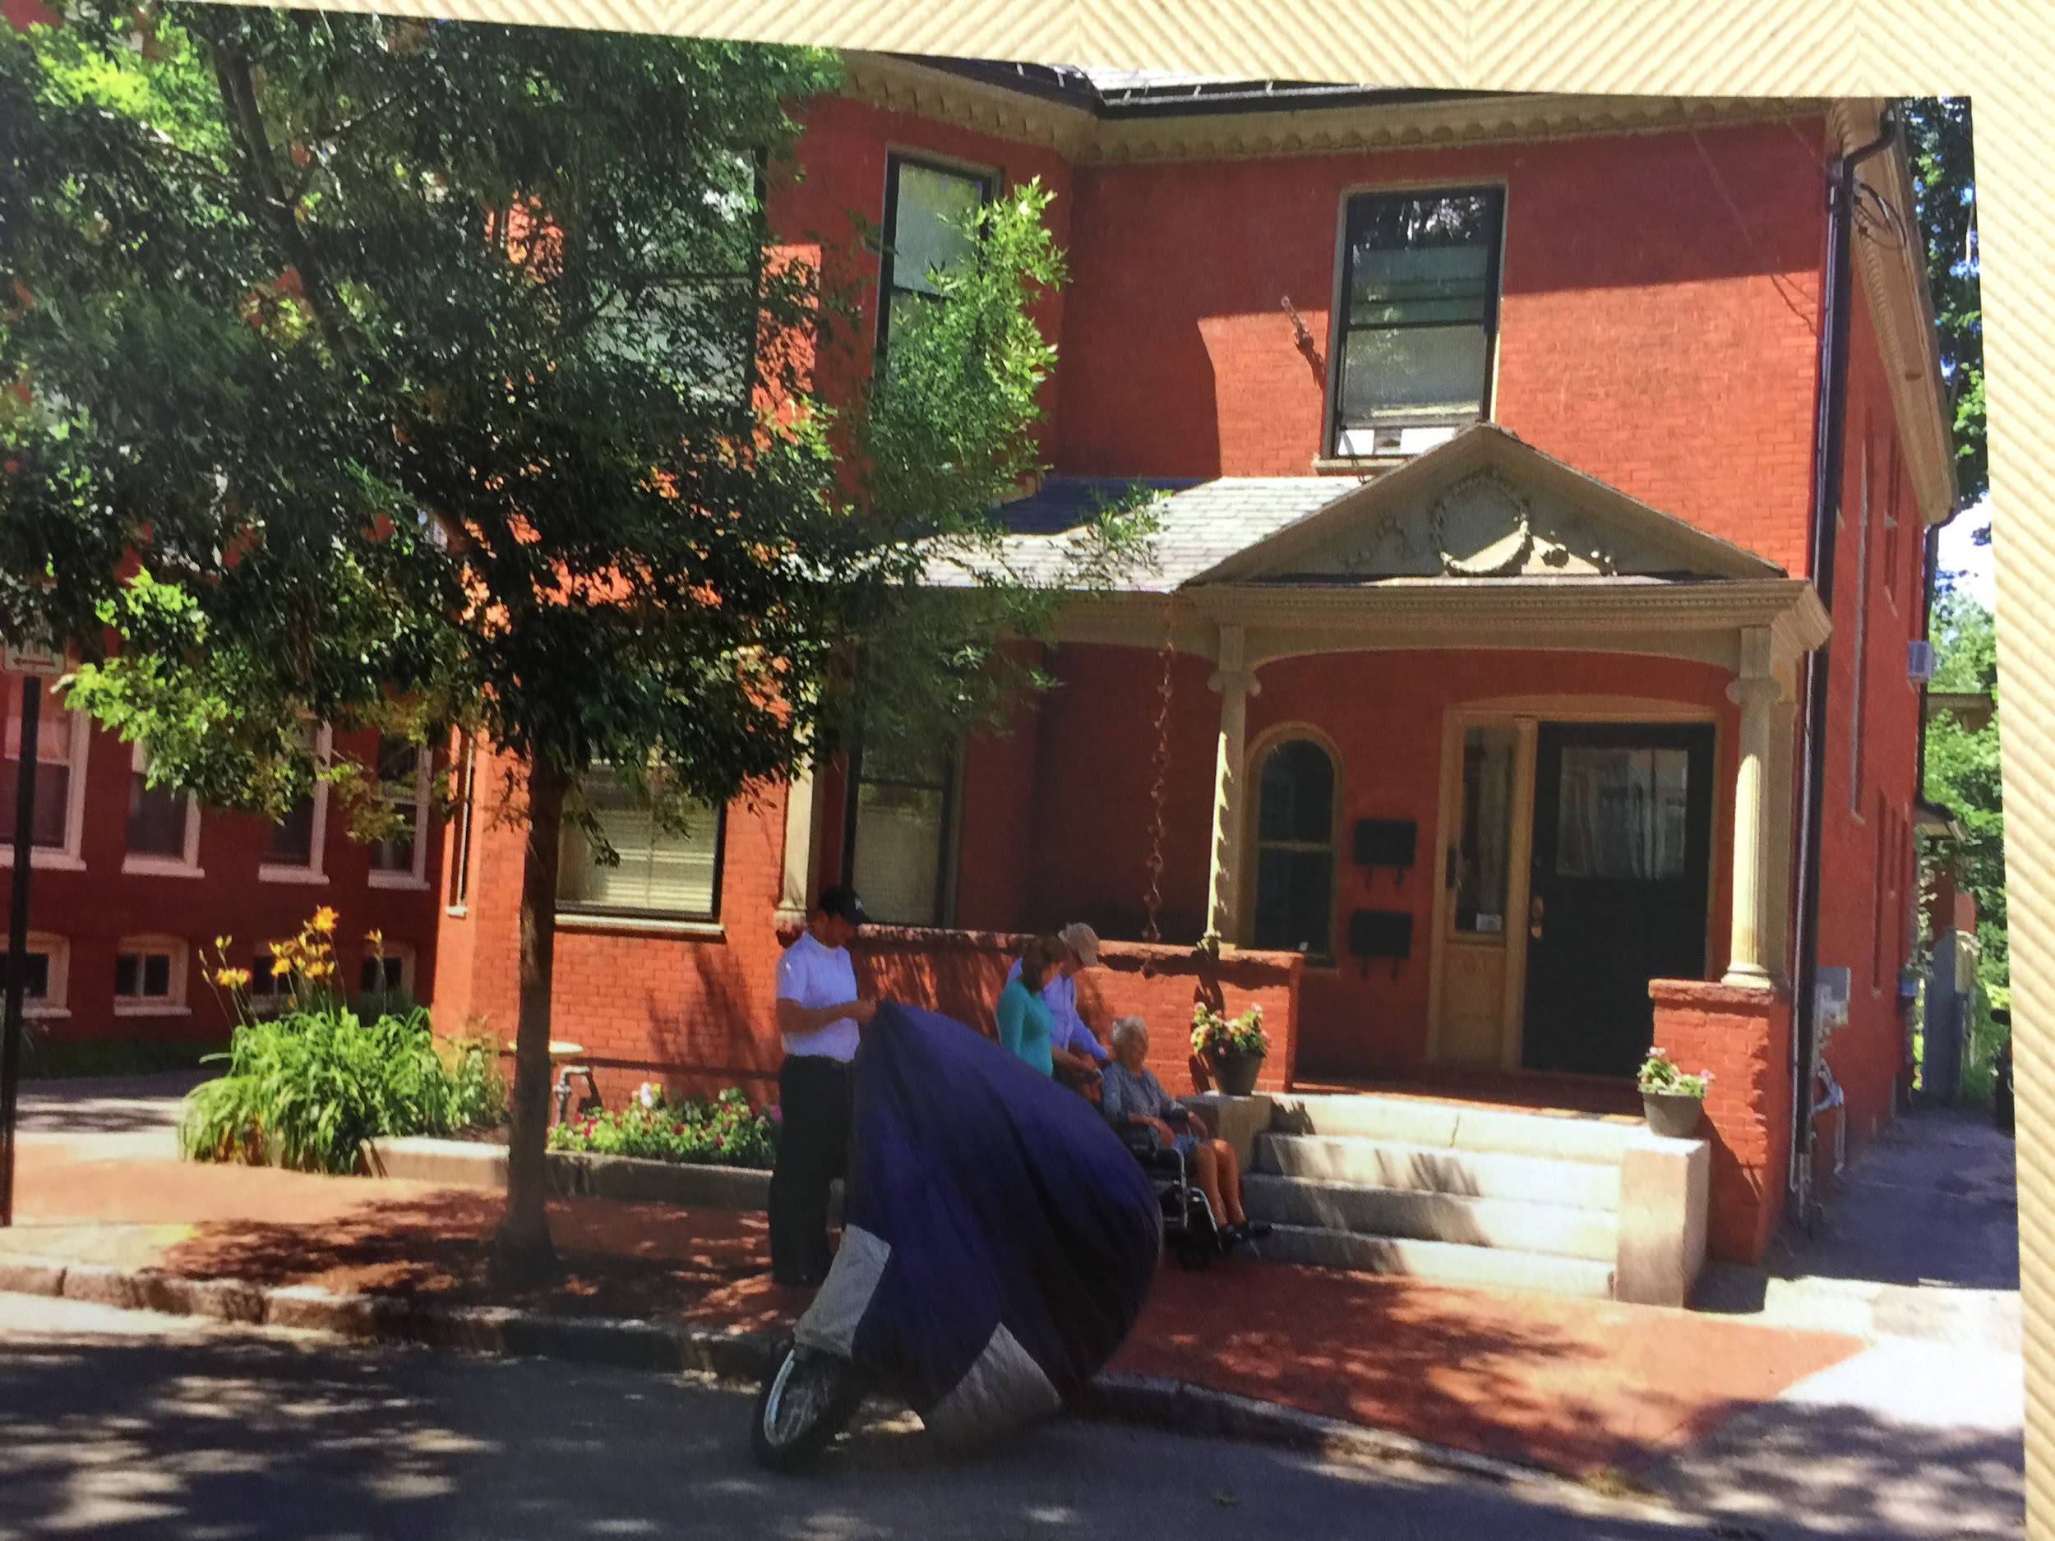

Davidson Home, 61 Sherman Street, Portland, Maine

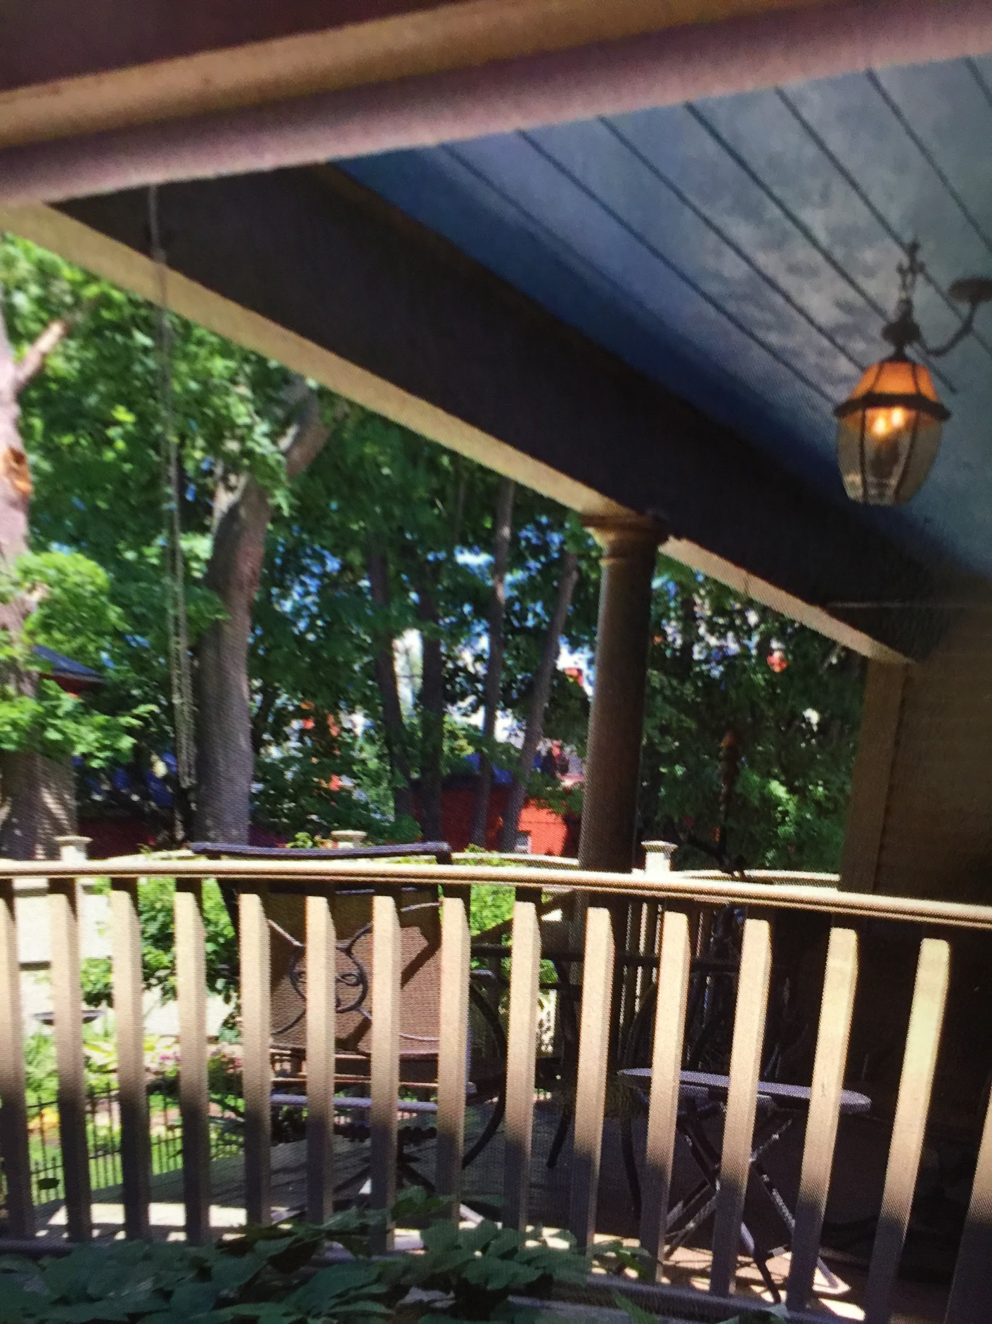

Back porch would be converted to a spacious, beautiful sukkah when the roof was raised. [Originally, they used old boards. Uncle Martin made decorations.]

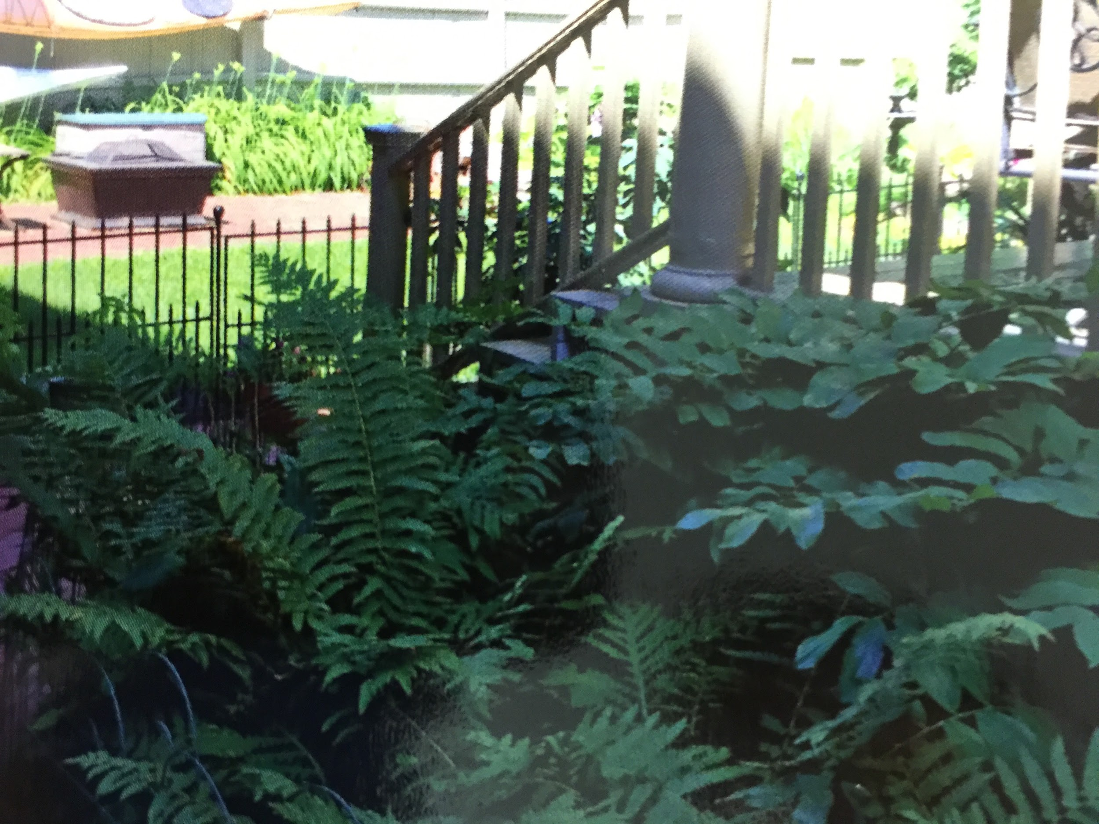

Backyard garden where Mama and Aunt Lilian used to work in the garden, and lie in the sun.

Source: Trip to Portland, Maine with Bubbie Sarah July 2015